WEB DEVELOPMENT LAB
Name: G V Akshith
Roll Number: 26001205
Section: CSM-6
EXPERIMENT 1: ONLINE SHOPPING WEBSITE
AIM
To create a responsive e-commerce website displaying products, prices, discounts, ratings, categories, product descriptions and shopping buttons. To design a responsive product grid, promotional banners and a shopping navigation bar using HTML and CSS.
SOURCE CODE
HTML Code (shopping.html)

<!DOCTYPE html>
<html lang="en">
<head>
<meta charset="UTF-8">
<meta name="viewport" content="width=device-width, initial-scale=1.0">
<title>OrangeCart - Online Shopping</title>
<link rel="stylesheet" href="shopping.css">
</head>
<body>

<!-- Navigation Bar -->
<header>
<h2 class="logo">OrangeCart</h2>

<nav>
<a href="#home">Home</a>
<a href="#categories">Categories</a>
<a href="#products">Products</a>
<a href="#offers">Offers</a>
<a href="#contact">Contact</a>
</nav>

<a href="#products" class="cart">🛒 Shop Now</a>
</header>

<!-- Promotional Banner -->
<div class="banner" id="home">
<div class="banner-content">
<h1>Big Shopping Festival!</h1>
<p>Discover amazing products at exciting prices.</p>
<h2>Up to 50% OFF</h2>
<a href="#products" class="btn">Shop Now</a>
</div>
</div>

<!-- Categories -->
<div class="section" id="categories">
<h2>Shop by Category</h2>

<div class="categories">
<a href="#electronics" class="category">Electronics</a>
<a href="#fashion" class="category">Fashion</a>
<a href="#accessories" class="category">Accessories</a>
<a href="#home-products" class="category">Home Products</a>
</div>
</div>

<!-- Products -->
<div class="section" id="products">
<h2>Featured Products</h2>

<div class="product-grid">

<!-- Product 1 -->
<div class="product-card" id="electronics">
<div class="discount">30% OFF</div>
<img src="https://placehold.co/300x220/fff0df/f07818?text=Headphones"
alt="Wireless Headphones">
<div class="product-info">
<p class="category-name">Electronics</p>
<h3>Wireless Headphones</h3>
<p class="description">
Enjoy clear sound and comfortable listening.
</p>
<p class="rating">★★★★☆ (4.2)</p>
<p class="price">₹1,399 <del>₹1,999</del></p>
<button onclick="alert('Demo: Headphones selected!')">
Add to Cart
</button>
</div>
</div>

<!-- Product 2 -->
<div class="product-card" id="fashion">
<div class="discount">25% OFF</div>
<img src="https://placehold.co/300x220/fff0df/f07818?text=Sneakers"
alt="Casual Sneakers">
<div class="product-info">
<p class="category-name">Fashion</p>
<h3>Casual Sneakers</h3>
<p class="description">
Stylish and lightweight shoes for everyday use.
</p>
<p class="rating">★★★★★ (4.5)</p>
<p class="price">₹1,499 <del>₹1,999</del></p>
<button onclick="alert('Demo: Sneakers selected!')">
Add to Cart
</button>
</div>
</div>

<!-- Product 3 -->
<div class="product-card" id="accessories">
<div class="discount">20% OFF</div>
<img src="https://placehold.co/300x220/fff0df/f07818?text=Smart+Watch"
alt="Smart Watch">
<div class="product-info">
<p class="category-name">Accessories</p>
<h3>Smart Watch</h3>
<p class="description">
Track your daily activity with a modern design.
</p>
<p class="rating">★★★★☆ (4.0)</p>
<p class="price">₹2,399 <del>₹2,999</del></p>
<button onclick="alert('Demo: Smart Watch selected!')">
Add to Cart
</button>
</div>
</div>

<!-- Product 4 -->
<div class="product-card" id="home-products">
<div class="discount">40% OFF</div>
<img src="https://placehold.co/300x220/fff0df/f07818?text=Table+Lamp"
alt="Decorative Table Lamp">
<div class="product-info">
<p class="category-name">Home Products</p>
<h3>Table Lamp</h3>
<p class="description">
A beautiful lamp for your bedroom or study table.
</p>
<p class="rating">★★★★☆ (4.3)</p>
<p class="price">₹599 <del>₹999</del></p>
<button onclick="alert('Demo: Table Lamp selected!')">
Add to Cart
</button>
</div>
</div>

</div>
</div>

<!-- Special Offer Banner -->
<div class="offer-banner" id="offers">
<h2>Special Weekend Offer!</h2>
<p>Get extra savings on selected products.</p>
<a href="#products" class="btn">Explore Deals</a>
</div>

<!-- Contact -->
<div class="section contact" id="contact">
<h2>Contact Us</h2>
<p>Email: support@orangecart.example</p>
<p>Phone: 9876543210</p>
<p>Customer Support: Monday to Saturday</p>
</div>

<!-- Footer -->
<footer>
<p>&copy; 2026 OrangeCart. All Rights Reserved.</p>
<p>Online Shopping Made Easy!</p>
</footer>

</body>
</html>

CSS Code (shopping.css)

* {
margin: 0;
padding: 0;
box-sizing: border-box;
scroll-behavior: smooth;
}

body {
font-family: Arial, sans-serif;
background: #fffaf5;
color: #333;
line-height: 1.6;
}

header {
background: white;
padding: 18px 25px;
display: flex;
justify-content: space-between;
align-items: center;
box-shadow: 0 3px 10px #f0dfd0;
}

.logo {
color: #f07818;
font-size: 28px;
}

nav a {
text-decoration: none;
color: #333;
margin: 7px;
font-weight: bold;
}

nav a:hover {
color: #f07818;
}

.cart {
background: #f07818;
color: white;
padding: 9px 14px;
border-radius: 5px;
text-decoration: none;
}

.banner {
background: linear-gradient(120deg, #f07818, #ffb15c);
color: white;
text-align: center;
padding: 65px 20px;
}

.banner h1 {
font-size: 40px;
margin-bottom: 10px;
}

.banner p {
font-size: 18px;
}

.banner h2 {
margin-top: 15px;
font-size: 30px;
}

.btn {
display: inline-block;
background: white;
color: #e96b0c;
text-decoration: none;
padding: 11px 22px;
margin-top: 18px;
border-radius: 5px;
font-weight: bold;
}

.btn:hover {
background: #fff0df;
}

.section {
max-width: 1200px;
margin: 30px auto;
padding: 25px;
}

.section h2 {
color: #e96b0c;
text-align: center;
margin-bottom: 25px;
}

.categories {
display: flex;
justify-content: center;
flex-wrap: wrap;
gap: 15px;
}

.category {
background: white;
border: 2px solid #f07818;
color: #e96b0c;
padding: 12px 20px;
border-radius: 25px;
text-decoration: none;
}

.category:hover {
background: #f07818;
color: white;
}

.product-grid {
display: grid;
grid-template-columns: repeat(4, 1fr);
gap: 22px;
}

.product-card {
background: white;
border-radius: 10px;
overflow: hidden;
box-shadow: 0 3px 12px #eadbce;
}

.product-card:hover {
transform: translateY(-5px);
}

.product-card img {
width: 100%;
height: 190px;
object-fit: cover;
}

.discount {
background: #f07818;
color: white;
padding: 5px 9px;
border-radius: 4px;
font-size: 12px;
}

.product-info {
padding: 16px;
}

.category-name {
color: #e96b0c;
font-size: 13px;
font-weight: bold;
}

.product-info h3 {
margin: 5px 0;
}

.description {
color: #666;
font-size: 14px;
margin: 8px 0;
}

.rating {
color: #f07818;
margin: 8px 0;
}

.price {
color: #e96b0c;
font-size: 20px;
font-weight: bold;
}

.price del {
color: #888;
font-size: 14px;
}

.product-info button {
width: 100%;
background: #f07818;
color: white;
border: none;
padding: 11px;
margin-top: 12px;
border-radius: 5px;
cursor: pointer;
}

.product-info button:hover {
background: #d85d00;
}

.offer-banner {
background: #fff0df;
border-top: 3px solid #f07818;
border-bottom: 3px solid #f07818;
text-align: center;
padding: 40px 20px;
}

.offer-banner h2 {
color: #e96b0c;
margin-bottom: 10px;
}

.offer-banner .btn {
background: #f07818;
color: white;
}

.contact {
text-align: center;
}

footer {
background: #f07818;
color: white;
text-align: center;
padding: 20px;
}

OUTPUT
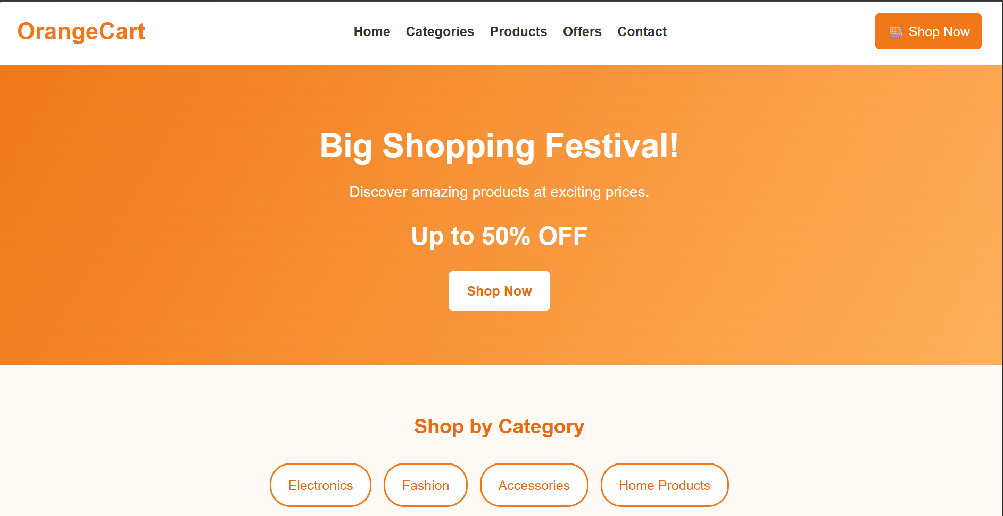
CONCLUSION
Successfully designed and developed a responsive online shopping website using HTML and CSS. The website displays product categories, product details, prices, discounts, ratings, promotional banners and shopping buttons with a user-friendly interface.
EXPERIMENT 2: COLLEGE INFORMATION AND ADMISSIONS WEBSITE
AIM
To design a college website displaying institutional information, departments, courses, faculty profiles, admission procedures, campus facilities, events and contact details. To create a navigation bar, banner and responsive information cards using HTML and CSS.
SOURCE CODE
HTML Code (college.html)

<!DOCTYPE html>
<html lang="en">
<head>
<meta charset="UTF-8">
<meta name="viewport" content="width=device-width, initial-scale=1.0">
<title>NRI Institute of Technology</title>
<link rel="stylesheet" href="college.css">
</head>
<body>

<!-- Navigation Bar -->
<header>
<h2>NRI Institute of Technology</h2>
<nav>
<a href="#home">Home</a>
<a href="#about">About</a>
<a href="#departments">Departments</a>
<a href="#faculty">Faculty</a>
<a href="#admissions">Admissions</a>
<a href="#facilities">Facilities</a>
<a href="#events">Events</a>
<a href="#contact">Contact</a>
</nav>
</header>

<!-- Banner -->
<div class="banner" id="home">
<div class="banner-content">
<h1>Welcome to NRI Institute of Technology</h1>
<p>Learn Today, Lead Tomorrow</p>
<a href="#admissions" class="btn">Explore Admissions</a>
</div>
</div>

<!-- About Institution -->
<div class="section" id="about">
<h2>About Our Institution</h2>
<p>
NRI Institute of Technology is an engineering college
located at Agiripalli, Andhra Pradesh. The institution
aims to provide quality technical education, encourage
innovation, and develop professional skills among students.
</p>
</div>

<!-- Departments and Courses -->
<div class="section" id="departments">
<h2>Departments and Courses</h2>

<div class="cards">
<div class="card">
<h3>Computer Science</h3>
<p>Learn programming, software development,
databases, and artificial intelligence.</p>
<p><b>Course:</b> B.Tech CSE</p>
</div>

<div class="card">
<h3>Information Technology</h3>
<p>Explore web technologies, networking,
cybersecurity, and information systems.</p>
<p><b>Course:</b> B.Tech IT</p>
</div>

<div class="card">
<h3>Electronics and Communication</h3>
<p>Study electronic circuits, communication
systems, and embedded technologies.</p>
<p><b>Course:</b> B.Tech ECE</p>
</div>

<div class="card">
<h3>Mechanical Engineering</h3>
<p>Learn about machines, manufacturing,
design, and engineering materials.</p>
<p><b>Course:</b> B.Tech Mechanical</p>
</div>

<div class="card">
<h3>Civil Engineering</h3>
<p>Explore construction, structural design,
surveying, and infrastructure development.</p>
<p><b>Course:</b> B.Tech Civil</p>
</div>

<div class="card">
<h3>Electrical Engineering</h3>
<p>Study electrical machines, power systems,
and electrical circuit design.</p>
<p><b>Course:</b> B.Tech EEE</p>
</div>
</div>
</div>

<!-- Faculty Profiles -->
<div class="section" id="faculty">
<h2>Our Faculty</h2>

<div class="cards">
<div class="card">
<h3>Faculty Member 1</h3>
<p>Department: Computer Science</p>
<p>Specialization: Programming</p>
</div>

<div class="card">
<h3>Faculty Member 2</h3>
<p>Department: Electronics</p>
<p>Specialization: Communication Systems</p>
</div>

<div class="card">
<h3>Faculty Member 3</h3>
<p>Department: Mechanical</p>
<p>Specialization: Machine Design</p>
</div>
</div>
</div>

<!-- Admissions -->
<div class="section" id="admissions">
<h2>Admissions</h2>
<p>Students interested in joining the institution can follow
the admission process listed below.</p>

<ol>
<li>Check eligibility requirements for the selected course.</li>
<li>Review the applicable entrance examination and counselling process.</li>
<li>Submit the application and required documents.</li>
<li>Complete document verification and fee payment as applicable.</li>
</ol>

<a href="#contact" class="btn">Admission Enquiry</a>
</div>

<!-- Campus Facilities -->
<div class="section" id="facilities">
<h2>Campus Facilities</h2>

<div class="cards">
<div class="card">
<h3>Library</h3>
<p>Books, reference materials, and learning resources.</p>
</div>

<div class="card">
<h3>Laboratories</h3>
<p>Practical learning and technical experiments.</p>
</div>

<div class="card">
<h3>Computer Labs</h3>
<p>Computing resources for programming and projects.</p>
</div>

<div class="card">
<h3>Sports</h3>
<p>Opportunities for physical activity and teamwork.</p>
</div>

<div class="card">
<h3>Transportation</h3>
<p>Student transport information and facilities.</p>
</div>

<div class="card">
<h3>Campus Life</h3>
<p>Student clubs, activities, and cultural programmes.</p>
</div>
</div>
</div>

<!-- Events -->
<div class="section" id="events">
<h2>College Events</h2>

<div class="cards">
<div class="card">
<h3>Technical Fest</h3>
<p>Technical competitions, project demonstrations,
and innovation activities.</p>
</div>

<div class="card">
<h3>Cultural Fest</h3>
<p>Music, dance, talent shows, and cultural programmes.</p>
</div>

<div class="card">
<h3>Workshops</h3>
<p>Learning sessions on emerging technologies
and professional skills.</p>
</div>
</div>
</div>

<!-- Contact Details -->
<div class="section" id="contact">
<h2>Contact Us</h2>
<p><b>Institution:</b> NRI Institute of Technology</p>
<p><b>Location:</b> Agiripalli, Andhra Pradesh, India</p>
<p><b>Email:</b>drrvrnriu@example.com</p>
<p><b>Phone:</b>987654321</p>
<p><b>Website:</b>https://rvrnriuniversity.edu.in/</p>
</div>

<!-- Footer -->
<footer>
<p>&copy; 2026 NRI Institute of Technology.
College Website Project.</p>
</footer>

</body>
</html>

CSS Code (college.css)

* {
margin: 0;
padding: 0;
box-sizing: border-box;
scroll-behavior: smooth;
}

body {
font-family: Arial, sans-serif;
background: #fffaf5;
color: #333;
line-height: 1.6;
}

header {
background: white;
padding: 18px 25px;
display: flex;
justify-content: space-between;
align-items: center;
box-shadow: 0 3px 10px #f2d7c5;
}

header h2 {
color: #f07818;
}

nav a {
color: #444;
text-decoration: none;
margin: 7px;
font-weight: bold;
}

nav a:hover {
color: #f07818;
}

.banner {
min-height: 350px;
background: linear-gradient(rgba(235,105,10,0.8), rgba(255,140,40,0.8)),
url("https://placehold.co/1600x600/f07818/ffffff?text=NRI+Institute+of+Technology") center/cover;
display: flex;
justify-content: center;
align-items: center;
text-align: center;
color: white;
padding: 20px;
}

.banner h1 {
font-size: 38px;
margin-bottom: 12px;
}

.banner p {
font-size: 22px;
}

.btn {
display: inline-block;
background: #f07818;
color: white;
padding: 12px 22px;
margin-top: 15px;
text-decoration: none;
border-radius: 5px;
font-weight: bold;
}

.btn:hover {
background: #d85d00;
}

.section {
max-width: 1100px;
margin: 25px auto;
padding: 35px 25px;
background: white;
border-radius: 10px;
border: 1px solid #ffe0c2;
box-shadow: 0 4px 12px #f5e5d8;
}

.section h2 {
text-align: center;
color: #e96b0c;
margin-bottom: 25px;
}

.section p {
margin-bottom: 12px;
}

.section ol {
padding-left: 25px;
margin-top: 15px;
}

.section li {
margin-bottom: 8px;
}

.cards {
display: flex;
flex-wrap: wrap;
justify-content: center;
gap: 20px;
}

.card {
background: #fff4e8;
padding: 22px;
border-radius: 8px;
flex: 1 1 250px;
max-width: 340px;
border: 1px solid #ffd2a6;
border-bottom: 4px solid #f07818;
}

.card h3 {
color: #e96b0c;
margin-bottom: 10px;
}

.card:hover {
background: white;
transform: translateY(-5px);
}

footer {
background: #f07818;
color: white;
text-align: center;
padding: 20px;
margin-top: 25px;
}

OUTPUT

CONCLUSION
Successfully designed and developed a college information and admissions website using HTML and CSS. The website provides information about the institution, departments, courses, faculty, admissions, campus facilities and events through a responsive and attractive layout.
EXPERIMENT 3: BAKERY AND CAKE SHOP WEBSITE
AIM
To create a responsive bakery website displaying cakes, pastries, cookies, custom cake designs, product prices, seasonal offers and store contact details. To design an attractive website using a suitable colour scheme, navigation bar, promotional sections and image galleries.
SOURCE CODE
HTML Code (bakery.html)

<!DOCTYPE html>
<html lang="en">
<head>
<meta charset="UTF-8">
<meta name="viewport" content="width=device-width, initial-scale=1.0">
<title>Sweet Crumbs Bakery</title>
<link rel="stylesheet" href="bakery.css">
</head>
<body>

<!-- Navigation Bar -->
<header>
<h2 class="logo">Sweet Crumbs 🍰</h2>
<nav>
<a href="#home">Home</a>
<a href="#cakes">Cakes</a>
<a href="#pastries">Pastries</a>
<a href="#cookies">Cookies</a>
<a href="#custom">Custom Cakes</a>
<a href="#offers">Offers</a>
<a href="#contact">Contact</a>
</nav>
</header>

<!-- Hero Banner -->
<div class="hero" id="home">
<div class="hero-content">
<p class="tagline">FRESHLY BAKED WITH LOVE</p>
<h1>Life Is Sweeter With Cake!</h1>
<p>
Delicious cakes, delightful pastries and
handmade cookies made fresh every day.
</p>
<a href="#cakes" class="btn">Explore Our Treats</a>
</div>
</div>

<!-- About Section -->
<div class="about">
<h2>Welcome to Sweet Crumbs</h2>
<p>
We bake every treat with love, care and the finest
ingredients. From birthday cakes to little sweet
moments, we make every occasion special.
</p>
</div>

<!-- Cakes Gallery -->
<div class="section" id="cakes">
<h2>Our Signature Cakes</h2>
<p class="subtitle">Made fresh for your sweetest moments</p>

<div class="gallery">
<div class="product">
<img src="https://images.unsplash.com/photo-1578985545062-69928b1d9587?auto=format&fit=crop&w=600&q=80"
alt="Chocolate celebration cake">
<h3>Chocolate Cake</h3>
<p>Rich chocolate layers with creamy frosting.</p>
<h4>₹650</h4>
<a href="#contact" class="small-btn">Order Now</a>
</div>

<div class="product">
<img src="https://images.unsplash.com/photo-1565958011703-44f9829ba187?auto=format&fit=crop&w=600&q=80"
alt="Fresh strawberry cake">
<h3>Strawberry Cake</h3>
<p>Fresh strawberries with soft vanilla cream.</p>
<h4>₹750</h4>
<a href="#contact" class="small-btn">Order Now</a>
</div>

<div class="product">
<img src="https://images.unsplash.com/photo-1464349095431-e9a21285b5f3?auto=format&fit=crop&w=600&q=80"
alt="Decorated birthday cake">
<h3>Birthday Cake</h3>
<p>A colorful cake for your special celebration.</p>
<h4>₹900</h4>
<a href="#contact" class="small-btn">Order Now</a>
</div>
</div>
</div>

<!-- Pastries Gallery -->
<div class="section alternate" id="pastries">
<h2>Delicious Pastries</h2>
<p class="subtitle">Little treats, big happiness</p>

<div class="gallery">
<div class="product">
<img src="https://images.unsplash.com/photo-1488477181946-6428a0291777?auto=format&fit=crop&w=600&q=80"
alt="Creamy dessert">
<h3>Vanilla Pastry</h3>
<p>Soft sponge with delicious vanilla cream.</p>
<h4>₹90</h4>
<a href="#contact" class="small-btn">Order Now</a>
</div>

<div class="product">
<img src="https://images.unsplash.com/photo-1576618148400-f54bed99fcfd?auto=format&fit=crop&w=600&q=80"
alt="Chocolate pastry">
<h3>Chocolate Pastry</h3>
<p>Chocolate sponge topped with silky ganache.</p>
<h4>₹110</h4>
<a href="#contact" class="small-btn">Order Now</a>
</div>

<div class="product">
<img src="https://images.unsplash.com/photo-1486427944299-d1955d23e34d?auto=format&fit=crop&w=600&q=80"
alt="Cupcakes with frosting">
<h3>Buttercream Cupcake</h3>
<p>Soft cupcakes with a sweet frosting swirl.</p>
<h4>₹75</h4>
<a href="#contact" class="small-btn">Order Now</a>
</div>
</div>
</div>

<!-- Cookies Gallery -->
<div class="section" id="cookies">
<h2>Freshly Baked Cookies</h2>
<p class="subtitle">Crunchy, sweet and irresistible</p>

<div class="gallery">
<div class="product">
<img src="https://images.unsplash.com/photo-1499636136210-6f4ee915583e?auto=format&fit=crop&w=600&q=80"
alt="Chocolate chip cookies">
<h3>Chocolate Chip Cookies</h3>
<p>Golden cookies filled with chocolate chips.</p>
<h4>₹150 / Box</h4>
<a href="#contact" class="small-btn">Order Now</a>
</div>

<div class="product">
<img src="https://images.unsplash.com/photo-1558961363-fa8fdf82db35?auto=format&fit=crop&w=600&q=80"
alt="Assorted handmade cookies">
<h3>Butter Cookies</h3>
<p>Delicate, buttery cookies baked to perfection.</p>
<h4>₹130 / Box</h4>
<a href="#contact" class="small-btn">Order Now</a>
</div>

<div class="product">
<img src="https://images.unsplash.com/photo-160 cookies"
alt="Assorted sweet treats">
<h3>Cookie Gift Box</h3>
<p>A lovely box of assorted sweet treats.</p>
<h4>₹250 / Box</h4>
<a href="#contact" class="small-btn">Order Now</a>
</div>
</div>
</div>

<!-- Custom Cakes -->
<div class="custom" id="custom">
<h2>Your Dream Cake, Our Creation!</h2>
<p>
Birthdays, weddings, anniversaries or any special day.
Tell us your theme, flavor and design ideas.
</p>

<div class="custom-gallery">
<img src="https://images.unsplash.com/photo-1535254973040-607b474cb50d?auto=format&fit=crop&w=600&q=80"
alt="Elegant custom celebration cake">

<img src="https://images.unsplash.com/photo-1550617931-e17a7b70dce2?auto=format&fit=crop&w=600&q=80"
alt="Beautiful decorated cake">

<img src="https://images.unsplash.com/photo-1562777717-dc6984f65a63?auto=format&fit=crop&w=600&q=80"
alt="Special occasion cake">
</div>

<a href="#contact" class="btn">Customize Your Cake</a>
</div>

<!-- Seasonal Offers -->
<div class="offers" id="offers">
<p>🎀 SWEET SEASONAL SPECIAL 🎀</p>
<h2>Make Every Celebration Sweeter!</h2>
<h3>Get 15% OFF on selected cake orders</h3>
<p>Perfect treats for birthdays, parties and family gatherings.</p>
<a href="#contact" class="btn">Grab Your Offer</a>
</div>

<!-- Contact Section -->
<div class="section contact" id="contact">
<h2>Visit Our Bakery</h2>
<p>📍 Address: Add your bakery address here</p>
<p>📞 Phone: Add your contact number here</p>
<p>✉ Email: hello@sweetcrumbs.example</p>
<p>🕒 Opening Hours: 9:00 AM – 9:00 PM</p>
<a href="mailto:hello@sweetcrumbs.example" class="btn">
Contact Us
</a>
</div>

<!-- Footer -->
<footer>
<h3>Sweet Crumbs Bakery</h3>
<p>Every bite tells a sweet story!</p>
<p>&copy; 2026 Sweet Crumbs Bakery. All rights reserved.</p>
</footer>

</body>
</html>

CSS Code (bakery.css)

* {
margin: 0;
padding: 0;
box-sizing: border-box;
scroll-behavior: smooth;
}

body {
font-family: Arial, sans-serif;
background-color: #fff9f5;
color: #493746;
line-height: 1.6;
}

header {
background: white;
padding: 18px 25px;
display: flex;
justify-content: space-between;
align-items: center;
box-shadow: 0 3px 10px #eadde8;
}

.logo {
color: #d66b91;
font-size: 26px;
}

nav a {
color: #493746;
text-decoration: none;
margin: 8px;
font-weight: bold;
}

nav a:hover {
color: #d66b91;
}

.hero {
min-height: 400px;
background: linear-gradient(rgba(0,0,0,0.5), rgba(0,0,0,0.4)),
url("https://images.unsplash.com/photo-1578985545062-69928b1d9587?auto=format&fit=crop&w=1600&q=80") center/cover;
display: flex;
justify-content: center;
align-items: center;
text-align: center;
color: white;
padding: 20px;
}

.hero-content {
max-width: 700px;
}

.tagline {
letter-spacing: 3px;
font-size: 13px;
}

.hero h1 {
font-size: 40px;
margin: 15px 0;
}

.btn, .small-btn {
display: inline-block;
background: #d66b91;
color: white;
padding: 10px 22px;
margin-top: 15px;
text-decoration: none;
border-radius: 25px;
font-weight: bold;
}

.btn:hover, .small-btn:hover {
background: #a94c76;
transform: translateY(-3px);
}

.about, .section {
max-width: 1100px;
margin: 30px auto;
padding: 35px 25px;
text-align: center;
}

h2 {
color: #b65c85;
margin-bottom: 15px;
}

.subtitle {
color: #8e7486;
margin-bottom: 25px;
}

.gallery, .custom-gallery {
display: grid;
grid-template-columns: repeat(3, 1fr);
gap: 20px;
margin-top: 25px;
}

.product {
background: white;
border-radius: 14px;
overflow: hidden;
padding-bottom: 20px;
box-shadow: 0 4px 12px #eadde8;
}

.product:hover {
transform: translateY(-5px);
}

.product img {
width: 100%;
height: 220px;
object-fit: cover;
}

.product h3 {
color: #a94c76;
margin: 12px;
}

.product p {
font-size: 14px;
padding: 0 12px;
}

.product h4 {
color: #d66b91;
font-size: 21px;
margin-top: 10px;
}

.alternate {
background: #f9edf5;
max-width: 100%;
}

.custom {
background: #f6e8f3;
text-align: center;
padding: 40px 20px;
}

.custom-gallery img {
width: 100%;
height: 230px;
object-fit: cover;
border-radius: 15px;
}

.custom-gallery img:hover {
transform: scale(1.03);
}

.offers {
background: linear-gradient(135deg, #d66b91, #a78bba);
color: white;
text-align: center;
padding: 40px 20px;
}

.offers h2 {
color: white;
font-size: 30px;
}

.offers .btn {
background: white;
color: #a94c76;
}

.contact {
background: white;
text-align: center;
border-radius: 15px;
box-shadow: 0 4px 12px #eadde8;
}

footer {
background: #493746;
color: white;
text-align: center;
padding: 25px;
}

footer h3 {
color: #f3b6cf;
}

OUTPUT
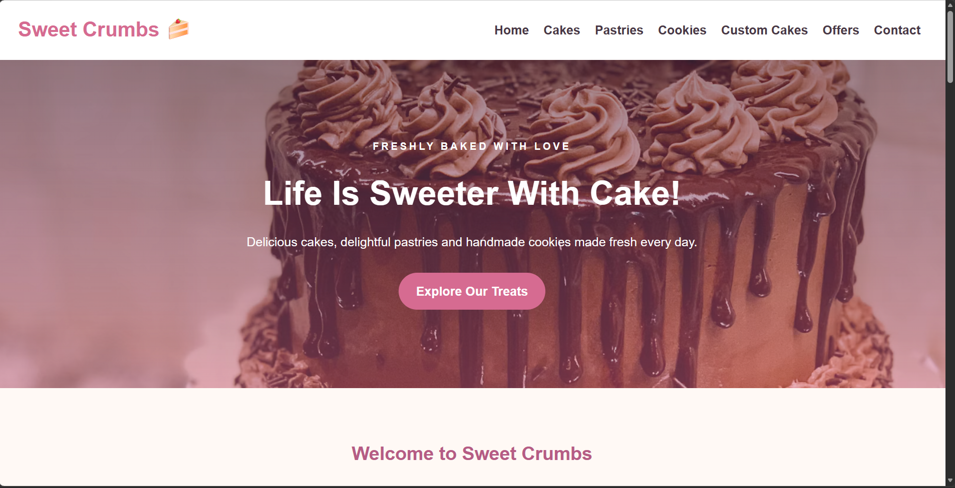
CONCLUSION
Successfully designed and developed a bakery and cake shop website using HTML and CSS. The website showcases different bakery products, prices, custom cake designs, seasonal offers and contact information using attractive image galleries and a responsive design.
OVERALL CONCLUSION
Successfully completed three web development experiments using HTML and CSS. Through these experiments, I gained practical knowledge of webpage structure, navigation bars, banners, responsive layouts, CSS styling, product cards, image galleries, animations and media queries. These experiments helped improve my understanding of designing attractive, user-friendly and responsive websites.

